CARRER LENS: CV/RESUME ANALYSER

A PROJECT REPORT

Submitted by

Sanskar Shinde 202401103145

Rohan Tarke 202401103149

Syed Aamer 202401103150

Sarvesh Ghodke 202401103158

For the subject Database Management Systems Lab

of

Third Year

IN

COMPUTER SCIENCE & ENGINEERING

Guided by
Prof. Sandip Kankal

Jawaharlal Nehru Engineering College, MGM University,
Ch. Sambhajinagar

YEAR 2026- 2027

CERTIFICATE

This is to certify that the project report
“Carrer Lens: CV/Resume Analyser”
Submitted by

Sanskar Shinde 202401103145

Rohan Tarke 202401103149

Syed Aamer 202401103150

Sarvesh Ghodke 202401103158

is a bonafide work carried out by them under the supervision of <<Name of Subject Teacher>> and it is approved for the subject Full Stack Development Lab in academic year 2026-2027 Part-II Semester IV at JNEC, MGM University, Ch. Sambhajinagar.

Date:

Name of Guide Dr. Deepa Deshpande
Guide Head of Department
Dept. of Computer Sci. & Engineering Dept. of Computer Sci. & Engineering

Dr. V. B. Musande
Principal
Jawaharlal Nehru Engineering College, MGM University, Ch. Sambhajinagar

CONTENTS

1. Mini Project on Carrer Lens: CV/Resume Analyser 1

1.1 Purpose 2
1.2 Relationship
1.3 Table and Attribute List
1.4 Cardinality
1.5 ER-Diagram
2. Normalisation 3

3. System Development 4-10
3.1 Database Implementation Details
(Screenshot or code for Create database, tables, demonstrate all sql commands as per project requirement)
3.2 Project Implementation (Screenshot GUI Design)

*******
Carrer Lens: CV/Resume Analyser

1.1 Purpose

In today’s competitive job market, companies receive hundreds of applications for every open position and rely on Applicant Tracking Systems (ATS) to screen, parse and rank resumes before a recruiter sees them. A large share of resumes is rejected automatically because of formatting problems, keyword mismatches or poor alignment with the job description (JD).
CareerLens is an automated Resume-to-Job matching and ATS scoring platform. It uses OpenCV (grayscale conversion and Otsu binarization) and Tesseract OCR to read resume images, and spaCy NLP (lemmatization and 300-dimensional word vectors) to compare the resume with a job description. The system computes an ATS compatibility score, lists exact and semantic skill matches, flags missing keywords, and stores every scan in a relational SQLite database so that the user can track improvement over time on a Matplotlib dashboard inside a Tkinter desktop application.

Problem addressed
- The “ATS black box”: candidates do not know why their resume is rejected.
- Lexical vs. semantic mismatch: plain keyword matching ignores synonyms and related phrasing.
- Image-based resumes (PNG/JPG exports) cannot be read by ordinary text parsers.
- No means of tracking how each resume revision affects the match score.
Objectives
- Ingest resume images and enhance readability through preprocessing.
- Extract text using OCR and normalise it.
- Match exactly (lemma intersection) and semantically (cosine similarity ≥ 0.75).
- Compute an ATS score (%) and show matched and missing skills.
- Persist users, resumes, job descriptions, scan history and keyword-level results in a normalised relational database (3NF).
- Visualise score history on an analytics dashboard.

1.2 Relationship
The database contains five entities. Their relationships are described below:
- A user can upload many resumes, but each resume belongs to exactly one user (USERS – RESUMES).
- A user can save many job descriptions, but each job description is created by one user (USERS – JOB_DESCRIPTIONS).
- A resume can be scanned many times (against different job descriptions or after revisions), and each scan record refers to one resume (RESUMES – ATS_HISTORY).
- A job description can be used in many scans, and each scan refers to one job description (JOB_DESCRIPTIONS – ATS_HISTORY).
- Each scan produces many keyword-level results (exact, semantic or missing), and each result belongs to exactly one scan (ATS_HISTORY – SKILL_MATCHES).
Because ATS_HISTORY links a resume with a job description, it acts as the associative (junction) entity of the many-to-many relationship between RESUMES and JOB_DESCRIPTIONS.

1.3 Table and Attribute List

Table 1: users
Attribute | Data Type | Key / Constraint | Description
user_id | INTEGER | PK, AUTOINCREMENT | Unique user identifier
email | TEXT | UNIQUE, NOT NULL | Login email
password_hash | TEXT | NOT NULL | Salted password hash
full_name | TEXT | NOT NULL | Name of account holder
role | TEXT | NOT NULL, DEFAULT ‘candidate’, CHECK | candidate / recruiter / admin
created_at | TIMESTAMP | DEFAULT CURRENT_TIMESTAMP | Account creation time
Table 2: resumes
Attribute | Data Type | Key / Constraint | Description
resume_id | INTEGER | PK, AUTOINCREMENT | Unique resume identifier
user_id | INTEGER | FK → users(user_id) | Owner of the resume
file_name | TEXT | NOT NULL | Original image file name
file_path | TEXT | NOT NULL | Storage path on disk
raw_text | TEXT | – | Text extracted via OCR
uploaded_at | TIMESTAMP | DEFAULT CURRENT_TIMESTAMP | Upload time

Table 3: job_descriptions
Attribute | Data Type | Key / Constraint | Description
jd_id | INTEGER | PK, AUTOINCREMENT | Unique job description ID
user_id | INTEGER | FK → users(user_id) | Creator of the JD
title | TEXT | NOT NULL | Target position title
company | TEXT | – | Hiring organisation
raw_text | TEXT | NOT NULL | Full JD text
created_at | TIMESTAMP | DEFAULT CURRENT_TIMESTAMP | Creation time

Table 4: ats_history
Attribute | Data Type | Key / Constraint | Description
id | INTEGER | PK, AUTOINCREMENT | Scan identifier
resume_id | INTEGER | FK → resumes(resume_id) | Resume that was scanned
jd_id | INTEGER | FK → job_descriptions(jd_id) | JD used for the scan
filename | TEXT | NOT NULL | Resume file label
score | INTEGER | NOT NULL, CHECK 0–100 | ATS compatibility score (%)
created_at | TIMESTAMP | DEFAULT CURRENT_TIMESTAMP | Scan time

Table 5: skill_matches
Attribute | Data Type | Key / Constraint | Description
match_id | INTEGER | PK, AUTOINCREMENT | Unique item ID
history_id | INTEGER | FK → ats_history(id), NOT NULL | Parent scan (ON DELETE CASCADE)
keyword | TEXT | NOT NULL | Evaluated lemma / keyword
match_type | TEXT | NOT NULL, CHECK | exact / semantic / missing
similarity_score | REAL | DEFAULT 1.0 | Cosine similarity (0.00–1.00)

1.4 Cardinality
Parent Table | Child Table | Cardinality | Foreign Key
users | resumes | 1 : N | resumes.user_id
users | job_descriptions | 1 : N | job_descriptions.user_id
resumes | ats_history | 1 : N | ats_history.resume_id
job_descriptions | ats_history | 1 : N | ats_history.jd_id
ats_history | skill_matches | 1 : N | skill_matches.history_id
resumes ↔ job_descriptions | (via ats_history) | M : N | Resolved by junction table

1.5 ER-Diagram
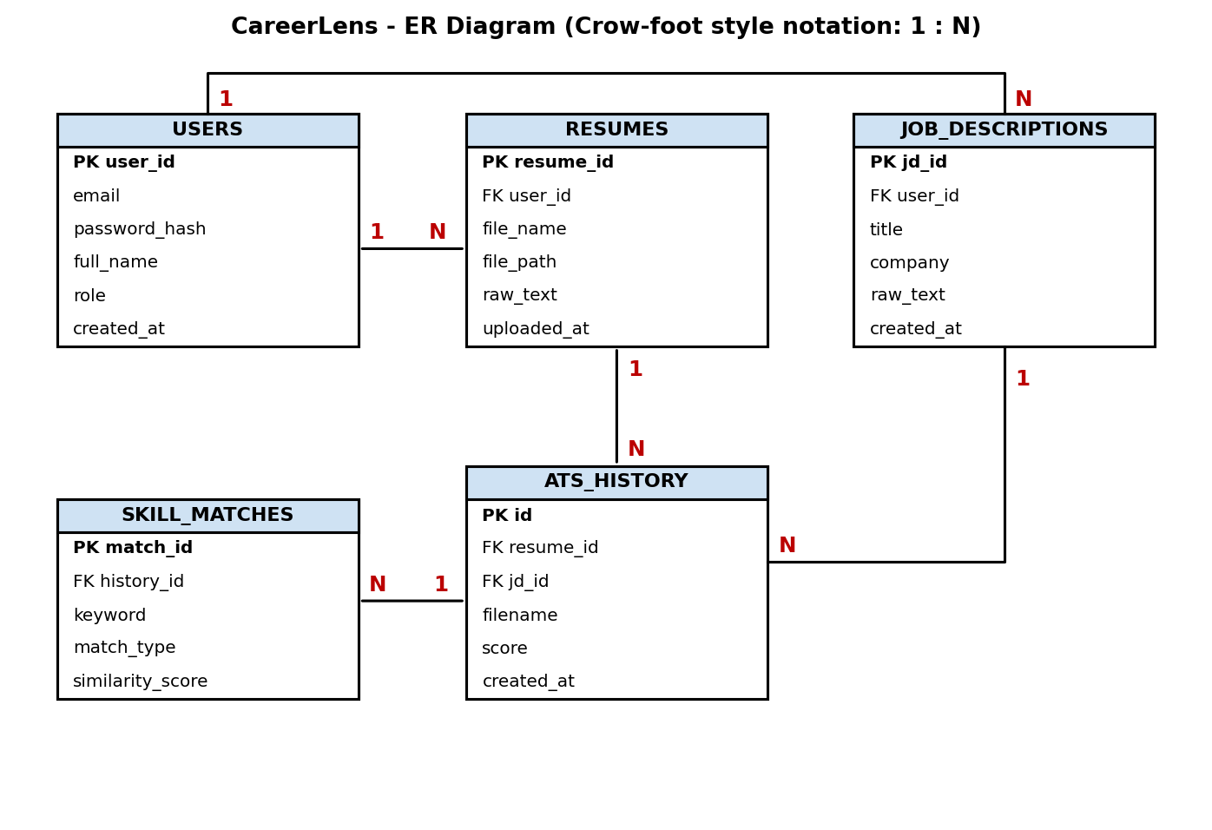
2. Normalisation
The schema was designed to satisfy Third Normal Form (3NF). The steps below show how a single un-normalised scan record is decomposed.
Un-normalised form (UNF)
A flat record could look like this, with repeating groups and repeated user / job data:
SCAN(user_email, full_name, resume_file, resume_text, jd_title, company,
jd_text, score, scan_time, {keyword, match_type, similarity}*)

First Normal Form (1NF)
1NF requires atomic values and no repeating groups. The repeating group {keyword, match_type, similarity} is moved into its own rows, so every column holds a single value and every row is identified by a primary key. In CareerLens each keyword result is one row of skill_matches with its own match_id, and no column stores lists.
Second Normal Form (2NF)
2NF requires that no non-key attribute depends on only part of a composite key. After 1NF, the flat key would be (scan, keyword), but attributes such as resume_file, jd_title and score depend only on the scan, not on the keyword. They are separated: scan-level data goes to ats_history, and keyword-level data stays in skill_matches. All tables use single-column surrogate keys, so partial dependencies cannot occur.
Third Normal Form (3NF)
3NF removes transitive dependencies (non-key attribute → non-key attribute). In the flat record, the following dependencies exist:
- user_email → full_name, role (user details), so these are moved to users.
- resume_file → file_path, raw_text (resume details), so these are moved to resumes.
- jd_title → company, jd_text (job details), so these are moved to job_descriptions.
Each remaining table holds attributes that depend only on its primary key.
Functional dependencies of the final schema
- user_id → email, password_hash, full_name, role, created_at
- resume_id → user_id, file_name, file_path, raw_text, uploaded_at
- jd_id → user_id, title, company, raw_text, created_at
- id → resume_id, jd_id, filename, score, created_at
- match_id → history_id, keyword, match_type, similarity_score
In every dependency the determinant is a candidate key, so the schema also satisfies Boyce–Codd Normal Form (BCNF). Normalisation removes data redundancy, avoids update, insert and delete anomalies, and the foreign keys with ON DELETE rules keep the data consistent.

3. System Development
Table Creation Code (DDL)

1. USERS TABLE
CREATE TABLE IF NOT EXISTS users (
user_id INTEGER PRIMARY KEY AUTOINCREMENT,
email TEXT NOT NULL UNIQUE,
password_hash TEXT NOT NULL,
full_name TEXT NOT NULL,
role TEXT NOT NULL DEFAULT 'candidate' CHECK(role IN ('candidate', 'recruiter', 'admin')),
created_at TIMESTAMP DEFAULT CURRENT_TIMESTAMP
);

2. RESUMES TABLE
CREATE TABLE IF NOT EXISTS resumes (
resume_id INTEGER PRIMARY KEY AUTOINCREMENT,
user_id INTEGER,
file_name TEXT NOT NULL,
file_path TEXT NOT NULL,
raw_text TEXT,
uploaded_at TIMESTAMP DEFAULT CURRENT_TIMESTAMP,
FOREIGN KEY (user_id) REFERENCES users(user_id) ON DELETE CASCADE
);

3. JOB DESCRIPTIONS TABLE
CREATE TABLE IF NOT EXISTS job_descriptions (
jd_id INTEGER PRIMARY KEY AUTOINCREMENT,
user_id INTEGER,
title TEXT NOT NULL,
company TEXT,
raw_text TEXT NOT NULL,
created_at TIMESTAMP DEFAULT CURRENT_TIMESTAMP,
FOREIGN KEY (user_id) REFERENCES users(user_id) ON DELETE SET NULL
);

4. ATS HISTORY TABLE (Core Project Table)
CREATE TABLE IF NOT EXISTS ats_history (
id INTEGER PRIMARY KEY AUTOINCREMENT,
resume_id INTEGER,
jd_id INTEGER,
filename TEXT NOT NULL,
score INTEGER NOT NULL CHECK(score >= 0 AND score <= 100),
created_at TIMESTAMP DEFAULT CURRENT_TIMESTAMP,
FOREIGN KEY (resume_id) REFERENCES resumes(resume_id) ON DELETE SET NULL,
FOREIGN KEY (jd_id) REFERENCES job_descriptions(jd_id) ON DELETE SET NULL
);

5. SKILL MATCHES BREAKDOWN TABLE
CREATE TABLE IF NOT EXISTS skill_matches (
match_id INTEGER PRIMARY KEY AUTOINCREMENT,
history_id INTEGER NOT NULL,
keyword TEXT NOT NULL,
match_type TEXT NOT NULL CHECK(match_type IN ('exact', 'semantic', 'missing')),
similarity_score REAL DEFAULT 1.0,
FOREIGN KEY (history_id) REFERENCES ats_history(id) ON DELETE CASCADE
);
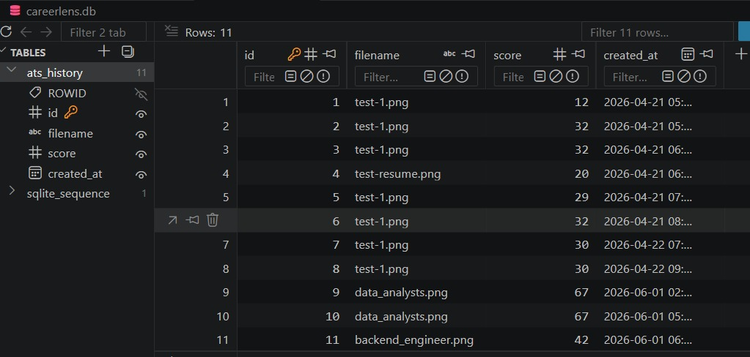

3.2 Project Implementation (Screenshot GUI Design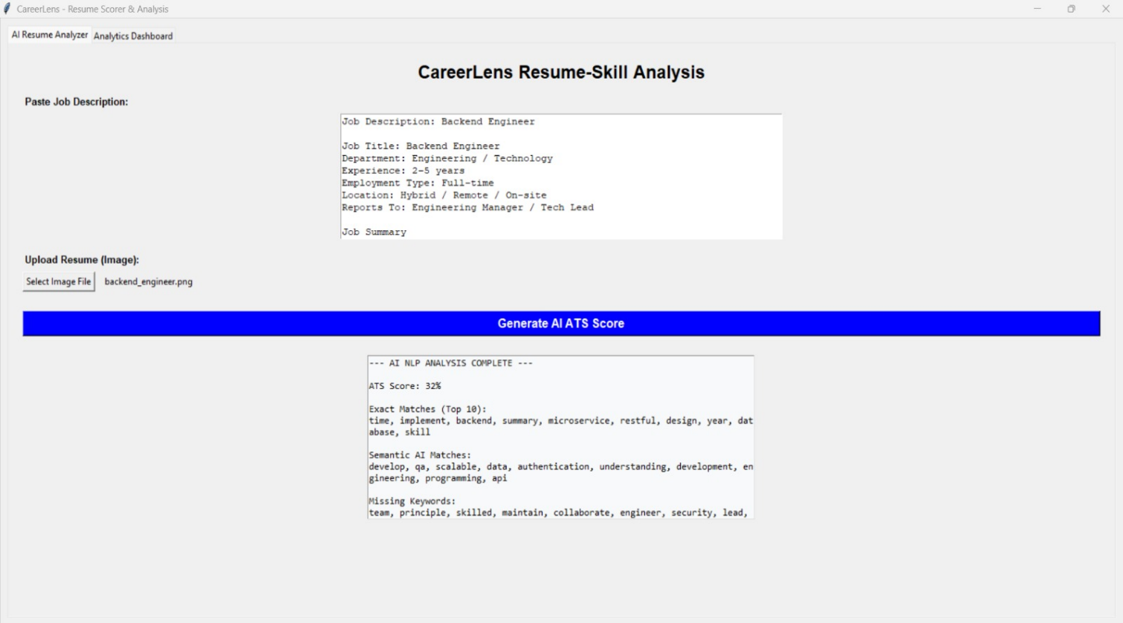
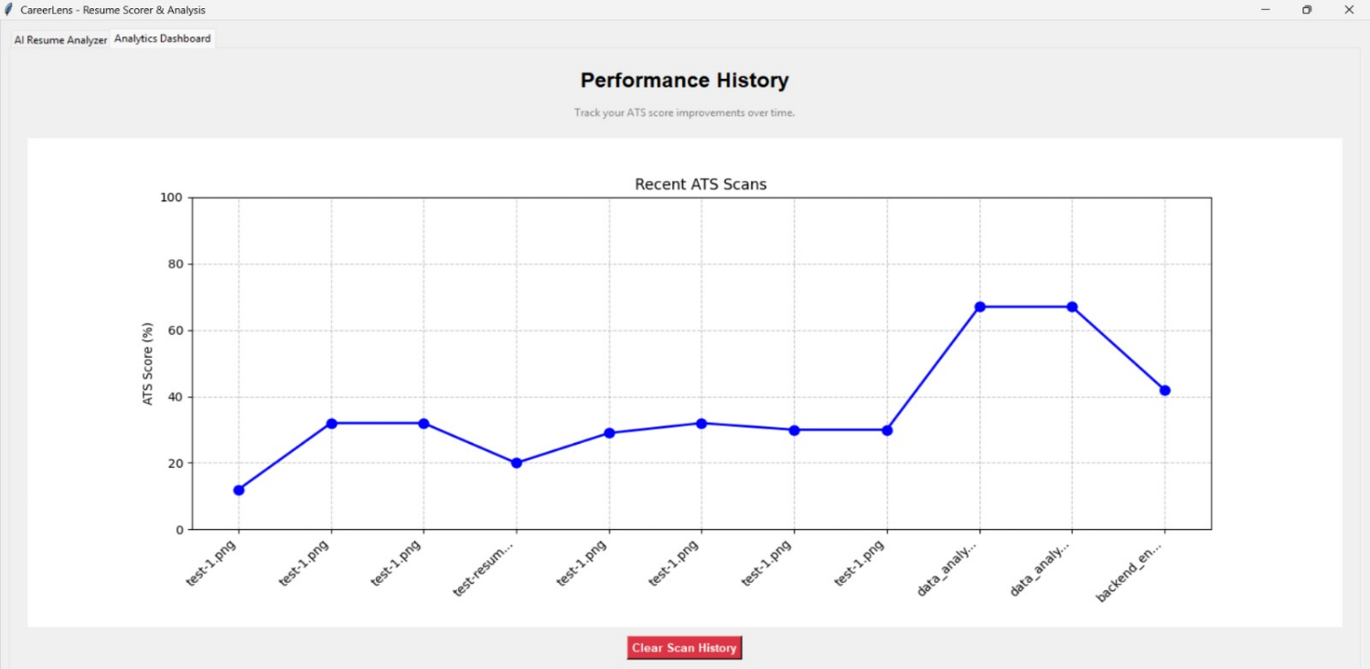

Conclusion
CareerLens provides a transparent bridge between job applicants and automated recruitment filters. By combining OpenCV preprocessing, Tesseract OCR and spaCy semantic vectors, it goes beyond simple keyword counting. The relational database in 3NF stores users, resumes, job descriptions, scan history and keyword-level diagnostics, and the dashboard lets applicants measure the improvement of each resume revision.

